EVALUATION REPORT
Predictive Modeling for Breast Cancer Diagnosis: A Classification Framework
Prepared For: Portfolio of Evidence (PoE) – Part 2
Author: Itumeleng Tlhale
Date: May 20, 2026
Executive Summary
The objective of this analysis is to evaluate the clinical patient measurements to classify breast tissue masses as either Malignant (M) or Benign (B). Using UCI Breast Cancer Wisconsin dataset (Breast_Cancer.csv), an end-to-end machine learning pipeline was constructed. This process involved comprehensive Exploratory Data Analysis (EDA), structured data cleaning, categorical transformation, feature selection, and comparative algorithm training.
Multiple predictive models were trained using an 75/25 train-test separation framework. The performance of these models was evaluated using statistical validation metrics: Accuracy, Precision, Recall, and the F1-Score.
Justification for Using the Breast Cancer Dataset for Classification Models
The UCI Breast Cancer Wisconsin dataset is well-suited for classification models because it contains a clearly defined binary target variable (benign vs malignant), structured numerical features, and strong relationships between variables.
The dataset is clean, with no missing or duplicate values, and has a balanced representation of both classes. Additionally, its size is appropriate for training and testing models effectively.
These characteristics make it ideal for applying classification algorithms such as Logistic Regression, Decision Trees, and Random Forest to accurately predict tumor diagnosis.
Dataset Overview & Basic Information
Before executing data modifications, the baseline dataset structure was queried to map out features and determine data types:
- Initial Profile Dimensions: The dataset comprises 569 records across 32 columns.
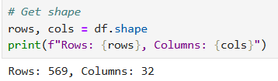
Exploratory Data Analysis (EDA) & Data Cleaning Outcomes
To ensure high-quality model training, raw data fields were systematically cleaned, checked for consistency, and transformed.
Structural Refinements and Duplicate Evacuation
- Removal of Irrelevant Identifiers: The id column was dropped from the data frame because a patient's database ID acts as a random identifier. Keeping it would cause the machine learning model to learn false patterns based on arbitrary tracking numbers.
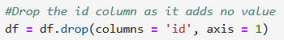
- Duplicate Assessment: A structural integrity check was performed using df.drop_duplicates(). The number of rows remained at 569, indicating that there were no duplicate records in the dataset.
Missing Value & Null Inspection
A comprehensive structural check was carried out using the df.info() function. The results showed a complete set of 569 non-null values across all 31 remaining columns. Since no missing data was identified, there was no need to remove any records.
Categorical Encoding of the Target Class
The dependent target classification variable, diagnosis, originally contained categorical text labels, where “M” represented Malignant tumours and “B” represented Benign tumours. Since machine learning algorithms require numerical input data, these categorical labels were converted into binary numerical values using value mapping as follows:
- Malignant (M) – 1
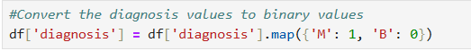
- Benign (B) – 0

This transformation enabled the machine learning models to process the diagnosis variable mathematically during classification and prediction tasks. The binary encoding approach is commonly used in supervised learning problems involving two-class classification outcomes.
A chart was used to show that there were more benign than malignant tumors in the patient’s data.
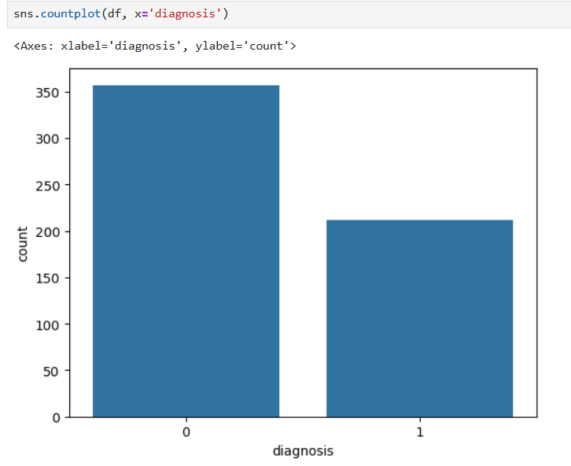

Identify patterns in the data
To help you understand relationships between multiple variables at the same time in a simple visual way, pair plots were used to illustrate this.
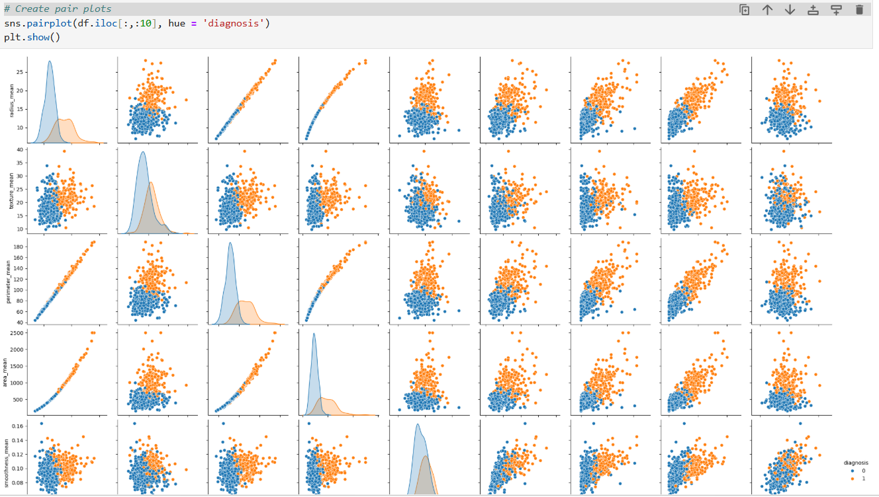
These plots show a clear separation between malignant and benign tumors. They also provide visual evidence that the dataset is suitable for building a classification model.
Correlation Exploration
It was observed that the cancer identification variables were grouped into 3 categories, i.e. mean, se and worst.
Three lists were created as per the identified categories.
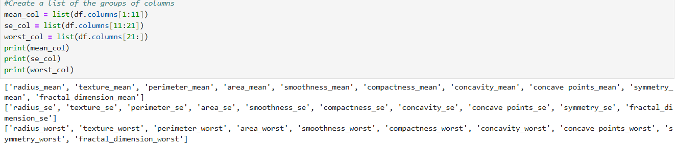
The diagnosis was appended to each of these list so that correlation could be determined between the diagnosis and the cancer variables.
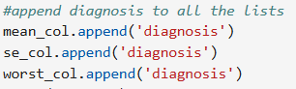
Heat maps were generated to show the correlation between the diagnosis and the cancer variables.
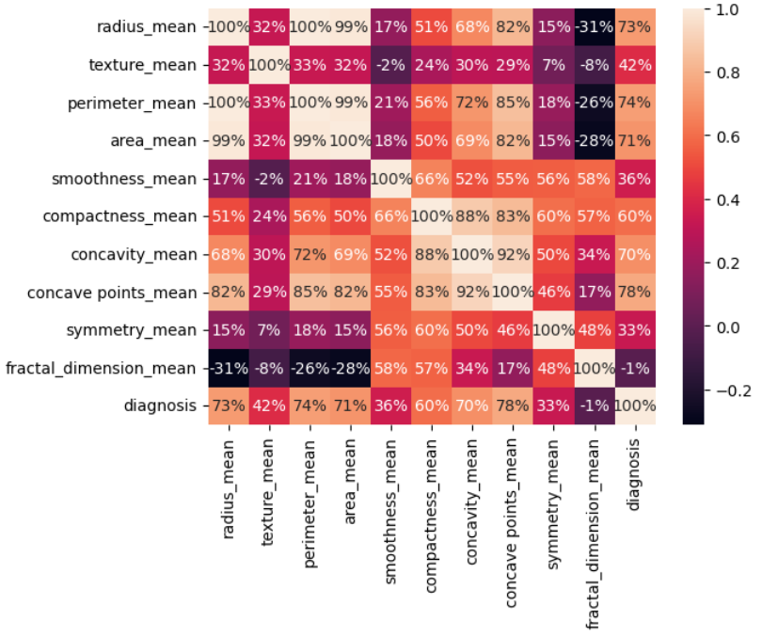
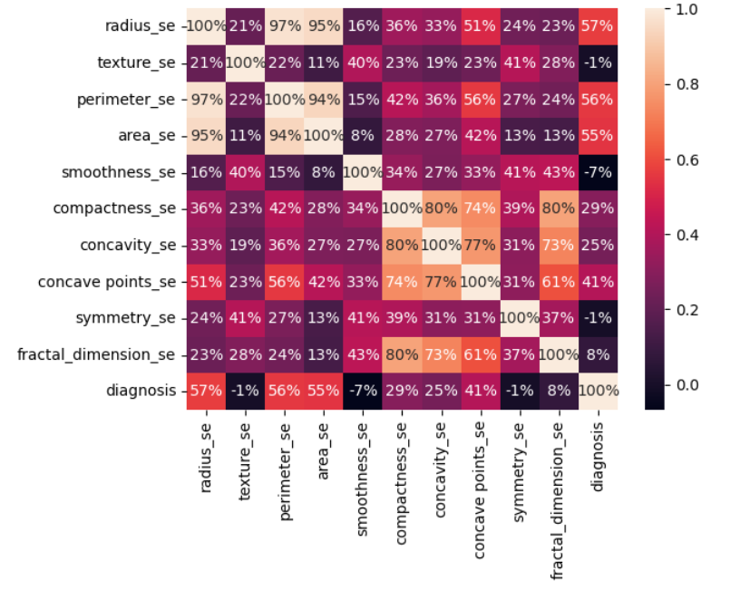
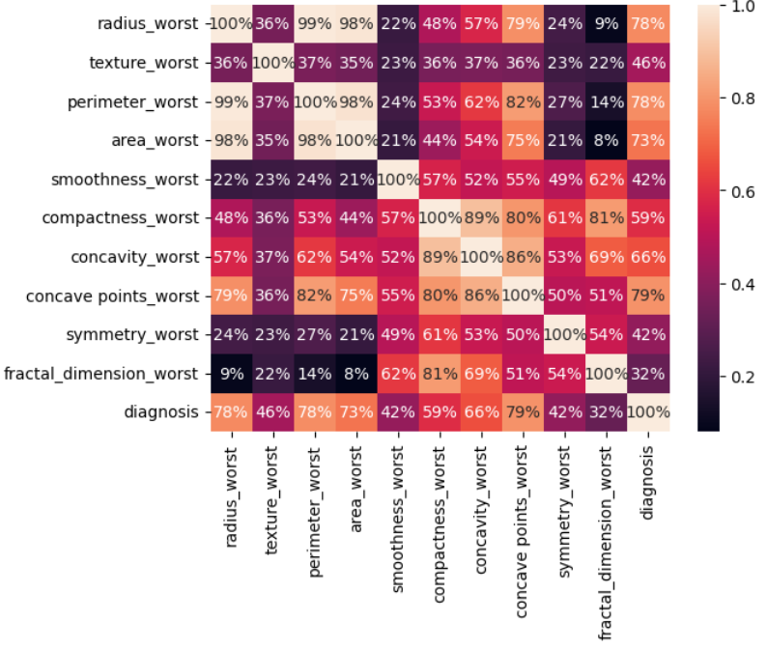
All the parameters with > 50% correlation to diagnosis were collated into one so that they may be used to train and test the models.
4. Model Training & Testing
4.1. Data Split
- The dataset was split using the train_test_split function from the Scikit-learn library. The data was divided into:
- 75% training data
- 25% testing data
- A fixed parameter (random_state = 0) was used to ensure that the split remains consistent each time the code is executed.
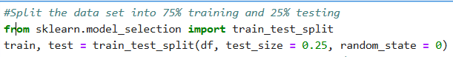
Scale the Training and Test data
Feature scaling was applied using the StandardScaler to standardise the input variables. This process ensures that all features have a similar scale, preventing variables with larger numerical values from dominating the model.
The training data was used to calculate the scaling parameters, and the same transformation was applied to the test data to maintain consistency.
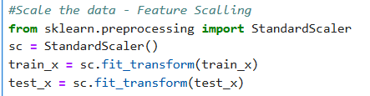
Build and Train the models
A function was created to build and train three different machine learning models:
- Logistic Regression
- Decision Tree
- Random Forest
Each model was trained using the training dataset and then evaluated by measuring its accuracy on the same data.
This approach allows for comparison between different algorithms to determine which model performs best for predicting whether a tumor is benign or malignant.
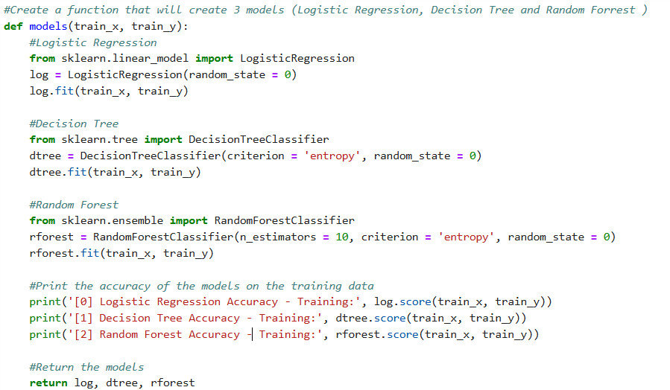
Training Results Interpretation
All models achieved very high accuracy, meaning:
- The dataset contains strong relationships between features and diagnosis.
- The models were able to learn the patterns effectively
Performance score on training data:
- Decision Tree – Best(100%)
- Random Forest – Very Close (99.5%)
- Logistic Regression – Still Strong (96.2%)
These results suggest that the models were able to learn the relationships within the dataset effectively, with the Decision Tree and Random Forest capturing patterns more precisely than Logistic Regression.
Testing the models
The trained models were evaluated using the testing dataset to measure their performance on unseen data. Each model generated predictions which were compared to the actual outcomes using a classification report and accuracy score.
The classification report provided detailed metrics such as precision, recall, and F1-score, while the accuracy score measured the overall correctness of predictions.
This process allows for a fair comparison of model performance and helps determine which algorithm is most suitable for predicting breast cancer diagnosis.
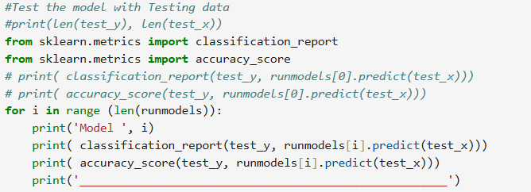
Interpretation of Test Result
These results show how well each model performs on the testing dataset (unseen data). This is the most important evaluation, as it reflects real-world performance.
Logistic Regression:
- Accuracy: 93%
- Key Observations:
  - Class 0 (Benign):
    - Precision: 0.98 - very accurate when predicting benign
    - Recall: 0.91 - Misses a few benign cases
  - Class 1 (Malignant):
    - Precision: 0.86 - Some incorrect malignant predictions
    - Recall: 0.96 - Very good at detecting cancer cases
Decision Tree:
- Accuracy: 91,6%
- Key Observations:
  - Class 0 (Benign):
    - Precision: 0.99 - Very accurate predictions
    - Recall: 0.88 - Misses more benign cases compared to other models
  - Class 1 (Malignant):
    - Precision: 0.83 - Lower precision
    - Recall: 0.98 - Extremely good at detecting cancer
Random Forrest:
- Accuracy: 95,1%
- Key Observations:
  - Class 0 (Benign):
    - Precision: 0.97, Recall: 0.96 – Very balanced
  - Class 1 (Malignant):
    - Precision: 0.93, Recall: 0.94 - Strong and consistent
Final Evaluation Performance Results
Model performance on the unseen testing dataset revealed that Random Forest was the top-performing model, achieving 95.1% accuracy with consistently high precision and recall.
Logistic Regression followed closely at 93% accuracy, excelling at malignant case identification.
The Decision Tree model lagged slightly at 91.6% accuracy; despite a high recall for malignant cases, it lacked overall class balance.
Consequently, Random Forest stands out as the most dependable model for breast

